Riversimple Movement Ltd
Vehicle Build Technicians

Overview: Riversimple Movement Limited are currently recruiting for additional vehicle build technicians.

Riversimple are pioneering in the development of hydrogen fuel cell vehicles, coupled with a unique infrastructure strategy and ownership arrangement, allowing us to provide sustainable personal moblity at no more cost than a standard small car.

We’re now expanding our team to build further beta test vehicles. Throughout the beta phase we intend to experiment, learn and implement multiple hardware and software iterations.
The role will suit technicians who thrive working with new technologies and are keen to use their experience to continuously improve the product and build process.
Prior experience with development vehicles or low volume production vehicles would be advantageous.
The successful candidates will have a proven track record working in a similar role preferably in motorsport or the automotive industry. You will be involved in general build and assembly as well as providing assistance to the engineering team on all vehicle related activities.

We are specifically looking for those within daily commutable distance to our workshops in Llandrindod Wells OR are able to relocate on short notice.

We are looking for someone who:

- Has excellent mechanical skills,
- Is able to work on own initiative, alone or as part of a team,
- Has energy, enthusiasm and initiative,
- Understands “what good looks like”,
- Has excellent communication and interpersonal skills,
- Has good general workshop skills including assembly and operation of workshop machinery.
Advantageous:
- Passionate about both the environment and preserving the joy and freedom of personal mobility,
- Experience in prototype or low volume vehicle assembly,
- Prior experience with electrified vehicles,
- Fabrication and/or machine shop skills.
In return we can offer you:
- the opportunity to work in an environmental sustainability driven company with a talented and committed team of staff,
- commitment to your professional development and growth,
- a chance to participate in solving one of the world’s biggest problems.

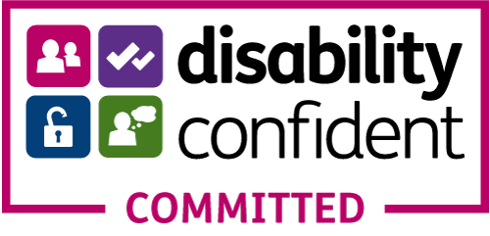
Please apply through the website here. If you have any questions, please contact info@riversimple.com.

